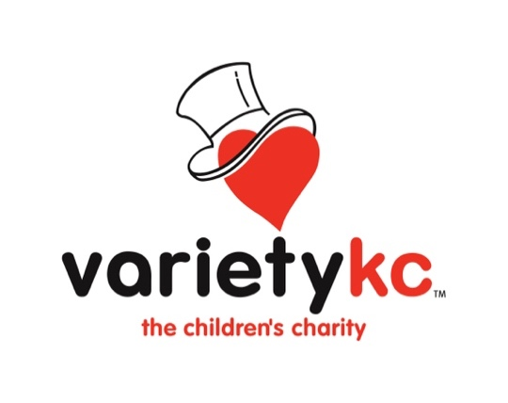
FOR IMMEDIATE RELEASE
Contact: Ali O’Grady
Community Liaison Officer
aogrady@varietykc.org
913.308.4042

VARIETY KC HELPS SHAWNEE MISSION SCHOOL DISTRICT CELEBRATE INCLUSION

Sept. 29th, 2023, Kansas City, MO – After a historic Request-a-Thon on KC 102.1, raising more than $175,000 for distributing 5 sensory bags to over 480 public schools in the Kansas City Metro, Variety KC is helping spread inclusivity and accessibility to school districts in even more ways.

Variety KC gifted Shawnee Mission School District $25,000 to help provide new adaptive equipment for inclusive recess and physical fitness for kids with disabilities to participate in recreational classes, and not just sit on the sidelines.

One of the pieces that will be featured at the celebration is the OverComer for Adapted Sports, which is a groundbreaking tool for improving accessibility to sports for children with disabilities. Whether a student or child has a cognitive disability, limited vision, or a physical disability limiting their ability to throw or swing, this is a way for them to learn skills that will have them playing sports they were previously unable to play. This is just one of the many examples of items purchased with the Variety KC grant received by SMSD.

Variety KC will also be dedicating a copy of the new book in their series, Variety Tales – Maddox’s Dream, published by Variety KC, to all district school libraries. This book will be read by Lenexa Hills Principal Michael Brewer. The Variety Tales book series helps to teach inclusion and representation of ALL kids to ALL students.

This special celebration will take place on Monday, October 2, at Lenexa Hills Elementary School at 1 p.m.

Play is a critical part of physical, emotional, mental, and social development for EVERY child! Especially for children with disabilities, play is therapy, both physical and emotional. On the physical side, children’s muscles need to be exercised just like anyone else’s. And most importantly, on the emotional side, children need to interact and socialize with their peers.

“Research shows that children with disabilities are an underserved population when it comes to physical fitness and health programing,” said Marc Harrell, Chief Inclusion Officer of Variety KC. “This is why it is so wonderful that districts, such as Shawnee Mission School District, can help make play and exercise more accessible.
In attendance will be Variety KC staff, Variety KC Kids with special needs and Shawnee Mission School District Representatives:
- Dr. Michelle Hubbard, Superintendent of SMSD
- Sherry Dumolien, Chief of Special Education for SMSD
- Michael Brewer, Principal of Lenexa Hills Elementary School

The celebration will be held at Lenexa Hills Elementary School; 8650 Haven Street in Lenexa, KS, 66219; and the program will begin at 1:00pm.

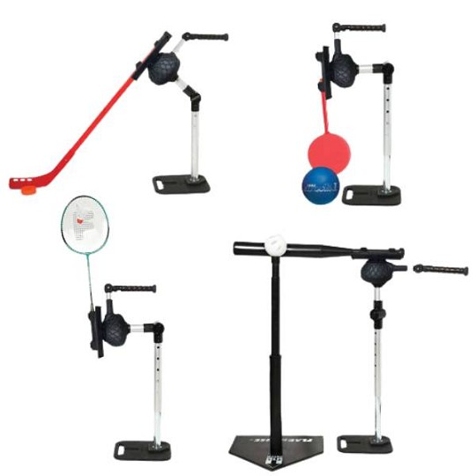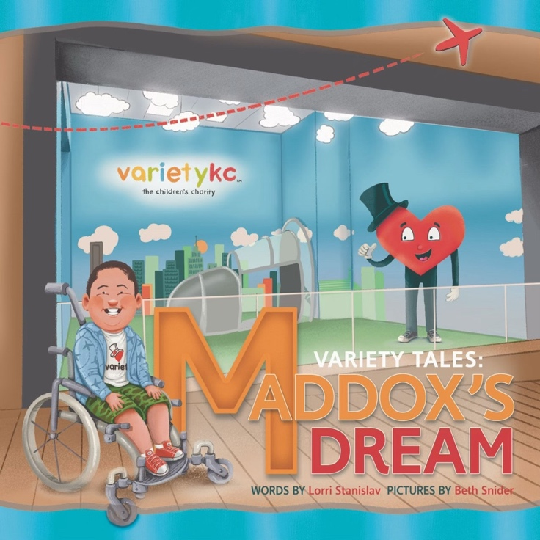

About Variety KC
Variety Children’s Charity empowers children with special needs and disabilities, in the Greater Kansas City region, by providing access to vital medical equipment for mobility, sensory, communication, safety, therapies, and more. Variety KC requests funds to underwrite the direct costs of these services. Grants and donations we receive will increase the number of families we can serve, continuing our history of positive impact while helping us to expand our coverage offerings to more and more families. All monies raised for Variety KC stays in the Greater Kansas City area. Variety’s inclusive mission provides essential mobility equipment and opportunities for children with cognitive and physical disabilities.

