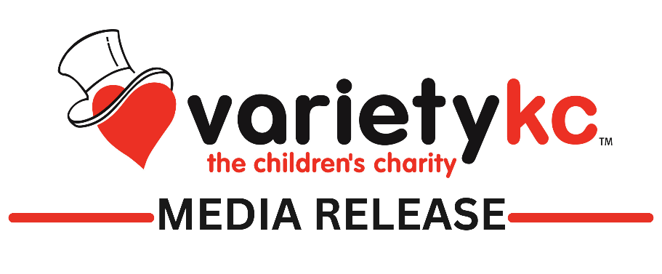
FOR IMMEDIATE RELEASE
Contact: Ali O’Grady
Community Liaison Officer
913-522-9723
aogrady@varietykc.org

Variety KC opens their 2nd all-inclusive Splash Pad in Lathrop
Lathrop, MO, June 1, 2023 – The Kansas City community is invited to attend the Summer Kick-off for Variety KC’s second all-inclusive Splash Pad.
When: Saturday, June 3rd, 2023, at 2:00pm
Where: 501 Park Street in Lathrop, Missouri
Who: Everyone is welcome!
Lathrop, Missouri, will be kicking off the summer opening of their inclusive playground and Variety KC congratulates them on this amazing accomplishment benefiting ALL kids and families!
After completing exciting updates to the Lathrop City Park, it’s time to put on your swimsuits, bring a towel, and enjoy some fun for ALL families. The Lathrop City Park Inclusive Playground is a fun and inclusive play area for children with all abilities, the only playground of its kind within a 40-mile radius of Lathrop, MO. This state-of-the-art playground project includes a custom splash pad to stay cool in the summer heat!
With summer upon us, water activities across the metro are filling up with children looking for a fun way to cool down on a hot day. However, there are not many opportunities where kids with special needs can cool off, get wet, and play alongside their able-bodied siblings and friends. These kids are left on the sidelines to watch their counterparts get wet, splash each other, and have fun because these play areas provide too many boundaries. Whether they cannot enter a playground due to the surface material, play on the equipment because it does not support their specific need, or maybe they cannot access the water to get wet. Now, thanks to this wonderful all-inclusive splash pad, kids with disabilities get to do just that. For the first time in this community, all kids with all abilities will be included in summertime water play.
Hy-Vee will offer free beverages and cookies to add to this summertime fun!
####
A town of just a couple thousand people, a million-dollar fundraising goal, and four years of hard work!
“There was a need to replace the playground, so there was an original fundraising group,” said Kendra Gagnon with Friends of Lathrop City Park. The idea of making the park inclusive first started picking up steam in the summer of 2019.
“Every child, every community, every family, needs a place to play and a place to gather,” Gagnon said.
The Friends of Lathrop City Park took planning seriously and went all the way to the state to help get the funding needed. They also teamed with Variety KC to make sure it was all-inclusive. Variety also stepped up to help fund the Splashpad portion of the park. Dr. Kendra Gagnon has worked closely with Variety on several projects as their Physical Therapy Advisor – but none were so close to the heart.

“I think people are surprised I think sometimes there’s even a little kind of disbelief that we actually got it done,” Gagnon said.

It was a million-dollar project, a big number for a town of its size. Even so, they have plans to expand – to add a bandstand and redo the basketball courts. “Something that we can say that we did, and something that we can give to our children,” Lathrop Mayor Jennifer Morrison said.

The group says their message to other smaller communities is that projects like this are possible. “There is nothing like it around, and I think we’re really proud to have something like it here in Lathrop,” Gagnon said. The mayor has already noticed families from other communities coming to Lathrop to hang out and play in the new park.

